Joe’s a tireless contributor

LIST OF COMMUNITY ROLES A MILE LONG
- Shepparton News
- 10 Jun 2019
- By Liz Mellino
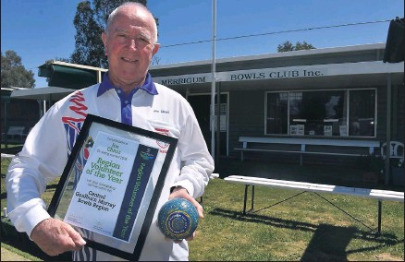
John (Joe) Chant after being awarded volunteer of the year for the Central Goulburn Murray Bowls Region.
Merrigum’s John Chant has spent most of his life serving the small communities he has resided in.
Known by most as Joe, the retired teacher and sporting stalwart has been recognised with an Order of Australia Medal.
While the news came as a complete surprise, Mr Chant said he initially thought the email he received informing him about the award was a lie.
‘‘Six months ago I got an email saying you have been nominated — I first thought it was a scam,’’ Mr Chant said.
‘‘I didn’t hear anything for ages and I thought it’s definitely a scam, nothing is going to happen.’’
However, he was soon proven wrong when he received an email a week ago from the Governor General’s Office saying he was being awarded an OAM for his service to the community of the Goulburn Valley.
‘‘I’m chuffed, I can’t believe it . . . something like this is beyond your wildest belief you would never think you would get an OAM for doing what you love,’’ Mr Chant said.
Mr Chant spent 45 years working as a teacher around the Goulburn Valley, with four of these years spent as the principal at Harston Primary School.
Aside from teaching he has a passion for local sport, contributing countless hours to a number of bowls, football and golf clubs across the region.
He has been an active member of the Merrigum Bowl Club since 1989, serving as the treasurer, secretary and vice-president during that time and is currently the chairman and publicity officer.
He has been an independent tribunal member for the Goulburn Valley Football League since 1990, an active member of the Merrigum Football Netball Club and a member of the Kyabram Catholic Parish Pastoral Council for many years.
Along with this he has been a committee member for the Merrigum and Murchison golf clubs.
‘‘I’ve always been in small communities — I have regarded those communities as my own and I have tried to improve them,’’ he said.
While he has strived to give back to the communities he has called home, Mr Chant said his effort would not have been possible without the support of his family.
In particular he thanked his wife Johanne and his children for their support during the years.
‘‘It sounds like I have done lots, but if it hadn’t been for my wife and family it would not have been possible to do anything, you cannot do anything by yourself,’’ Mr Chant said.
Looking back over his impressive list of achievements, Mr Chant said the highlight was being recognised as volunteer of the year for the Central Goulburn Murray Bowls Region.
Mr Chant was awarded last October for being the heart of the Merrigum Bowls Club, dedicating hours as the club’s president, while also skippering the side, organising transport, writing the match reports, stocking the fridge and working the bar.
‘‘That was a bit of a buzz to get that award . . . being awarded that for the work at the bowling club, to get volunteer of the year that was a great honour,’’ he said.
‘‘You don’t do it so people to say thank you, but it’s nice when someone recognises what you have done.’’

